To purchase the PADI eCard please follow the steps below:
1. Go to https://www.padi.com/
2. Click on Replace Your Card
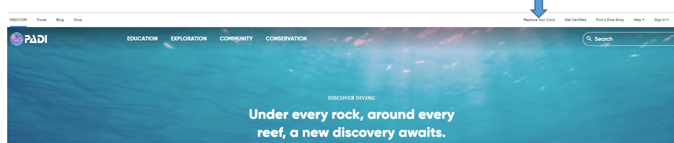​
3. Scroll down and select your shipping country and hit ‘Go!’ (even though this is an eCard this is necessary)
4. Scroll down and click Continue
5. Locate your records by entering your name exactly as it appears below
- First Name-
- Middle Initial-
- Last Name-
6. Update your shipping address (for an eCard this should be your billing address)
7. Upload a photo (if required)
8. Select the type of card you want to purchase= eCard
9. Proceed until payment is confirmed
At the end of the transaction you will be taken to the confirmation page which will include your username/password & a Temporary Card. Please input the username/password into the PADI App to pull up your eCard (internet access is necessary). You’re now ready to show proof of certification electronically!

